AGRIBUSINESS DATA ANALYTICS | FINAL REPORT

Business Insights, Reporting and Strategic Recommendations for Agribusiness
Week 5 Task | Junior Data Analyst - Agribusiness Internship | Yuva Intern
Prepared October 2026. Synthesises the analyses completed in Weeks 1 to 4.
Contents
- Executive Summary
- 1. Introduction and Scope
- 2. Methodological Overview
- 3. Key Findings Across the Analyses
- 4. Business Insights: Linking Findings to Agribusiness Challenges
- 5. Strategic Recommendations
- 6. Benefits and Pitfalls: Cross-Cutting View
- 7. Implementation Roadmap and Success Measures
- 8. Responsible Use, Ethics and Governance
- 9. Limitations of the Overall Evidence
- 10. Further Research
- 11. Conclusion
- Appendices A to D: data sources, key numbers, external context sources, glossary

Executive Summary

Purpose
This report converts five weeks of data work into decisions an agribusiness can act on. It combines a large public dataset of Indian crop area, production and yield (455,359 raw district records, 1997 to 2023) with a small farm-level dataset (50 farms), and asks three practical questions: can the data be trusted, what patterns matter for the business, and what should be done about them.

Key numbers at a glance | Value
APY records: raw / analysis-ready | 455,359 / 450,350 (5,009 removed, 1.1%)
Records flagged but kept (outliers or crop failures) | 18,448 (4.1% of analysis-ready records)
Wheat yield 1997 to 2022 (flagged rows excluded) | 1.90 to 2.73 t/ha (+43.2%)
2014-15 national wheat production change | -18.0 million tonnes (-17.5%); area -1.4%
Uttar Pradesh share of that net loss | About 64%; 74 of 75 districts fell
Farm dataset: farms / significant input effects found | 50 / none (8 tests)
Cross-validated R-squared of the farm yield model | -0.137 (worse than guessing the average)

What the analysis found
- Aggregate numbers mislead; segmented numbers work. Yield statistics pooled across crops are dominated by a few crops (pooled mean 69.6 versus median 1.07 t/ha). The area-to-production correlation is 0.04 when crops are pooled but 0.85 to 0.94 within each crop. Any dashboard that blends crops will mislead decisions.
- Climate shocks are the largest, most concentrated risk visible in the data. In the 2014-15 season, area-weighted national wheat yield fell 16.4% and production fell about 18.0 million tonnes (17.5%) while planted area was almost unchanged. Uttar Pradesh alone supplied about 64% of the net loss, 74 of its 75 districts recorded lower yields, and every major rabi crop in the state fell. Press and industry reports describe unseasonal rain and hail in March 2015, which fits the pattern, but this dataset contains no weather variables, so the cause is a well-supported hypothesis, not a proven result.
- Long-run productivity is improving. Wheat yield rose from about 1.90 to 2.73 t/ha between 1997 and 2022 (+43.2%). An all-crop series suggests a larger rise (+79%), but about 44% of that rise is just a changing crop mix.
- Data quality is a business risk in its own right. 5,009 records (1.1%) showed zero yield where production was simply unreported, a naive outlier rule wrongly flagged 14.6% of records, and 3,997 zero-production records cannot be classed as crop failure or reporting gap without a status field.
- Regional productivity gaps exist and need verification. 7.0% of Sugarcane records fall below 5 t/ha, concentrated in a few states (for example 77% of Chhattisgarh's Sugarcane records), but whether this reflects rain-fed farming or a reporting convention is not yet known.
- Farm inputs did not predict yield in the 50-farm dataset. Eight individual tests found nothing significant and a regression model scored worse than guessing the average on unseen farms (cross-validated R-squared -0.137). This shows the dataset is too small and lacks weather and soil variables, not that inputs do not matter.

What we recommend
- Make crop- and state-segmented, area-weighted reporting the standard for every yield and market dashboard (quick win, low cost).
- Install data-quality controls: report missing production as null, add a harvest-status field, and validate yields against crop-specific ranges (start in-house now, then agree changes at source).
- Build a climate-shock early-warning and response protocol for the rabi wheat belt, starting with Uttar Pradesh, Bihar, Punjab, Haryana and Rajasthan.
- Build a validated yield-monitoring and forecasting capability on the large APY dataset, judged against a simple baseline.
- Verify the Sugarcane low-yield clusters before investing, then target confirmed gaps.
- Invest in a farm-level data programme (weather, soil, inputs; at least about 350 farms) before offering input-optimisation advice, and pilot weather-index insurance once a weather-yield relationship is established.

Key caveats
All findings are associations in observational, district-level or small-sample data; none proves cause. Price, trade and supply-chain data were identified in Week 1 but not analysed, so recommendations on market competitiveness are limited to what supply-side evidence can support. Section 9 lists the full limits.

1. Introduction and Scope
Agribusinesses make decisions about procurement, storage, input supply, lending and investment under uncertainty about yields and markets. Public data can reduce that uncertainty, but only if it is trustworthy and read correctly. This internship project worked through that pipeline in five stages: identify data sources and metrics (Week 1), prepare the data (Week 2), explore it (Week 3), test statistical relationships and build a predictive model (Week 4), and finally translate the results into business recommendations (this report).

1.1 Datasets used
- Crop-Wise Area, Production and Yield (APY), India Data Portal: district-level records by crop, season and year (Ministry of Agriculture and Farmers Welfare), 1997 to 2023. Used in Weeks 2 and 3 and for the supply-side findings in this report.
- Agriculture and Farming Dataset (Kaggle): 50 farm records with inputs (area, fertilizer, pesticide, water), farm characteristics and yield. Used in Week 4.
- Three further sources were identified in Week 1 (FAOSTAT trade data, World Bank commodity price indices, World Bank agriculture and rural development indicators) and described, but not analysed. This matters for scope: the report's findings are about yield and production, not prices or trade.

1.2 Conventions used in this report
- Agricultural years: '2014-15' means the season sown in 2014 and harvested in 2015. Earlier weekly charts label this season '2014' (its start year).
- Yield is in tonnes per hectare (t/ha) for the APY data. 'Area-weighted yield' means total production divided by total area, which gives larger districts proportionately more weight than a simple average of district yields.
- Sizes are always labelled: APY raw (455,359 rows), APY analysis-ready (450,350 rows), farm dataset (50 farms).

2. Methodological Overview

2.1 How the five weeks fit together
Week | Business question | Data and size | Methods | Main output
1 | What data exist and what should be measured? | 5 public sources identified | Desk research; KPI design | Source register; 11 KPIs in 4 categories
2 | Is the APY data fit for analysis? | APY: 455,359 raw to 450,350 rows | Missing-value, duplicate and outlier checks; per-crop IQR; flagging | Cleaned dataset with is_outlier and crop_failure flags
3 | What patterns and anomalies exist? | APY: 450,350 rows | Summary statistics, distributions, correlation, trends, state and district comparison | Five evidenced findings (Section 3)
4 | Do farm inputs explain or predict yield? | Farm dataset: 50 farms | Pearson correlation, ANOVA, Levene, OLS regression, train/test, cross-validation | No reliable relationship; model has no predictive skill
5 | What should the business do? | Weeks 1 to 4 plus external context | Synthesis, impact and feasibility assessment, roadmap | This report

2.2 Principles that shaped the analysis
- Diagnose before cleaning. Each data problem was inspected before it was fixed. For example, missing production values were found to be recorded as zero yield, a defect that a blind fill or drop would have hidden.
- Flag, do not delete, when an extreme value might be real. Outliers and zero-production records were flagged and kept, because droughts, floods and bumper harvests are exactly the events a business needs to see.
- Segment before trusting an aggregate. Statistics were recomputed within crop (and state) whenever a pooled number looked surprising. This single habit changed the conclusion in three separate analyses.
- Validate on data the model has not seen. Models were judged on held-out farms using repeated splits and cross-validation, and compared with a 'guess the average' baseline.
- Report negative results honestly. All tests and all splits are reported, including unfavourable ones.

2.3 Refinements to earlier findings
Deeper checks carried out while preparing this report refined two statements made in the Week 3 report. The headline lesson (segment before trusting an aggregate) is unchanged, but the specific statements are:
- The 2014-15 wheat dip was broader than first described. Week 3 described it as concentrated in Uttar Pradesh with Punjab and Madhya Pradesh 'stable'. An area-weighted decomposition shows that eight of the ten largest wheat states fell (Bihar -42%, Uttar Pradesh -36%, Haryana -16%, Punjab -14%, Rajasthan -14%, Gujarat -12%), and only Madhya Pradesh rose (+20%). Uttar Pradesh remains the largest single contributor (about 64% of the net production loss) because it holds about 31% of national wheat area. The dip is therefore best described as a broad northern and eastern wheat-belt shock with Uttar Pradesh at its centre.
- Crop mix explains only part of the all-crop yield rise. Week 3 said the +79% all-crop rise was 'most likely' a crop-mix artefact. A direct test (holding the crop mix fixed at 1997 shares) gives +45%, so crop mix accounts for about 44% of the rise. The rest reflects genuine growth within crops and/or wider district coverage (the records used in this comparison, with flagged records excluded, number 10,277 for 1997 but 20,556 for 2022; counting all records the figures are 10,445 and 21,849). The all-crop figure still overstates productivity growth, but not by as much as stated.
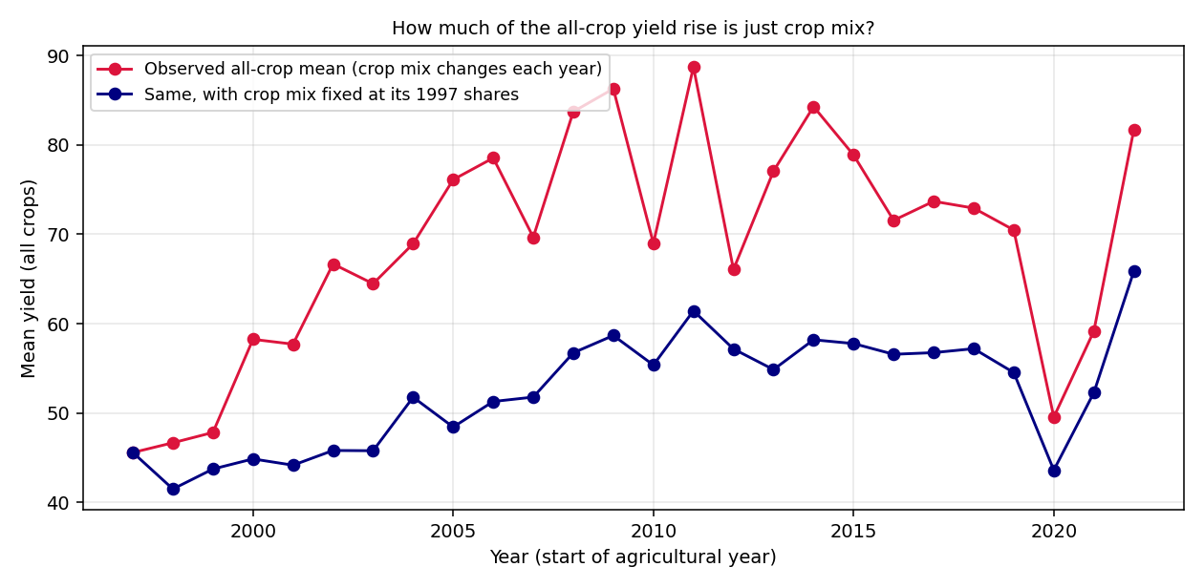
Figure 1: The all-crop yield rise (+79%) falls to +45% when the crop mix is held at its 1997 shares.

3. Key Findings Across the Analyses

3.1 Data readiness: the data can be used, with safeguards (Week 2)
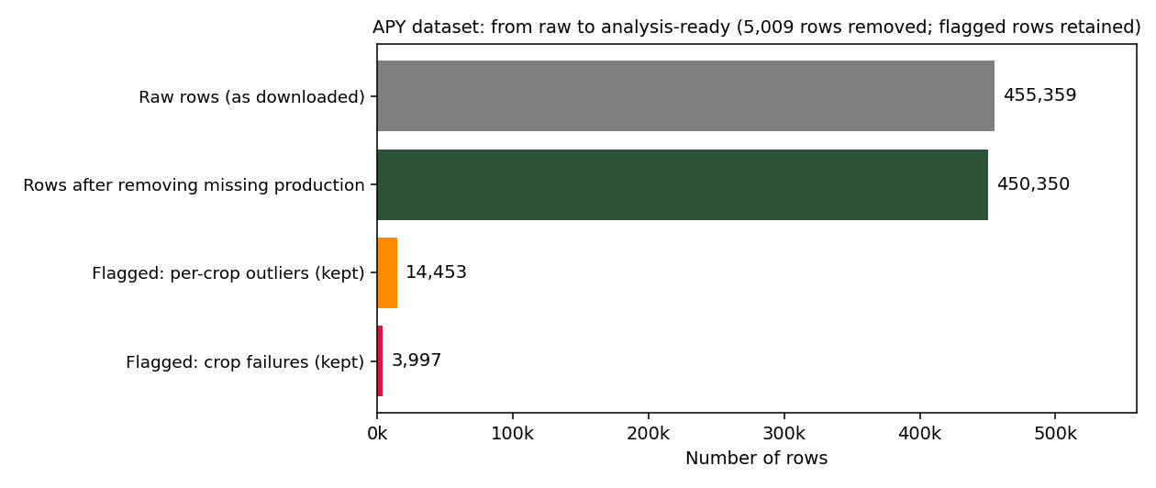
Figure 2: Records removed and records flagged in the APY dataset.
- Missing production, with a hidden defect. 5,009 records (1.1% of 455,359) had no production value, and in every one of them yield had been recorded as 0.0 instead of being left blank. They were removed, because imputing production could have masked genuine crop failures.
- No duplicates. Neither exact duplicates nor duplicates on year, state, district, crop and season were found.
- Outliers must be judged per crop. A single outlier threshold across all crops flagged 14.6% of records (65,857), purely because crops such as Coconut report yields thousands of times larger than cereals. Per-crop thresholds flagged 3.21% (14,453).
- Zero production is ambiguous. 3,997 records show cultivated area but zero production. They plausibly represent total crop failure but cannot be confirmed as such. Together with the outlier flags, 18,448 records (4.1%) are flagged; two records carry both flags.
Implication: the data supports analysis, but any business use must state whether flagged records are included (risk questions) or excluded (typical-performance questions).

3.2 Patterns and trends (Week 3)
- Pooled statistics are misleading. Mean yield is 69.6 t/ha against a median of 1.07 (standard deviation 866.5). Coconut's mean yield (8,975) is more than 150 times that of the next crop, so any pooled figure describes Coconut, not agriculture.
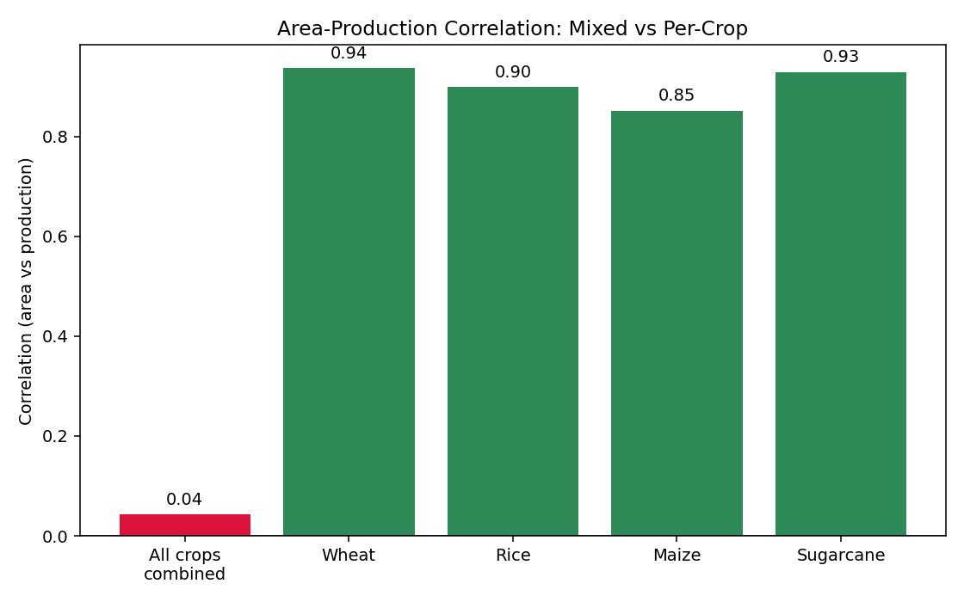
Figure 3: Area and production are almost uncorrelated when crops are pooled (0.04) but strongly correlated within each crop (0.85 to 0.94).
- Within a crop, land area predicts output well. For Wheat, the correlation of 0.936 means area accounts for about 88% of the variation in production (R-squared 0.876). Production planning should therefore be modelled crop by crop.
- Wheat productivity has risen steadily. Yield rose from 1.90 to 2.73 t/ha (1997 to 2022, flagged rows excluded), a gain of 43.2%, with a flat phase to about 2009 and the steepest sustained rise from 2015.
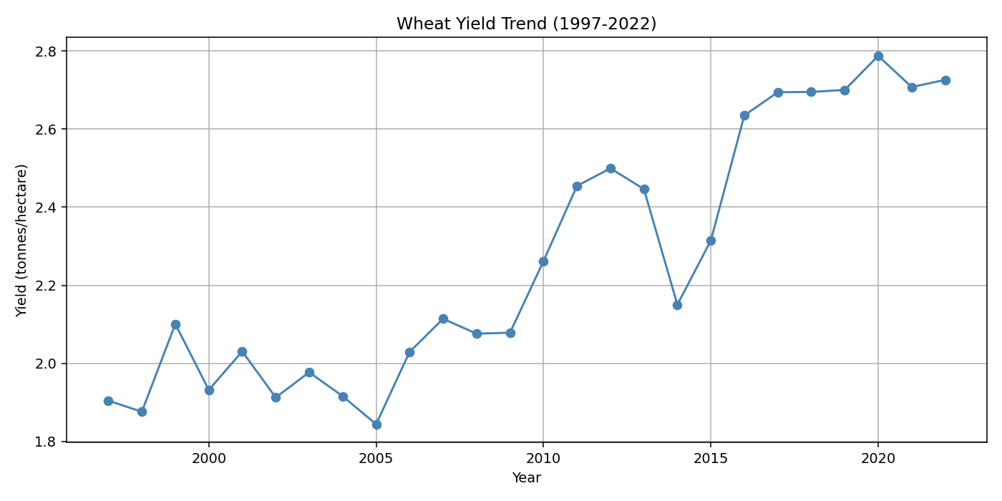
Figure 4: Wheat yield trend with the 2014-15 dip visible (chart label '2014').
- Sugarcane has two production systems. Its yield distribution has two humps. 869 of 12,367 Sugarcane records (7.0%) are below 5 t/ha, and 827 of them are unflagged, valid data. They are concentrated in a few states: Meghalaya 151 of 151 records, Jammu and Kashmir 37 of 44 (84%), Chhattisgarh 361 of 469 (77%), Mizoram 51 of 176 (29%), Himachal Pradesh 38 of 147 (26%) and Madhya Pradesh 153 of 1,061 (14%). The low-yield records recur across many years, so this is a persistent pattern, not a single bad season.

3.3 The 2014-15 wheat shock in detail
This is the largest anomaly in the data, and the checks below were designed to establish whether it is real before interpreting it.
- It is a yield event, not an area event. National wheat area was 31.62 million hectares in 2013-14 and 31.19 million in 2014-15 (-1.4%), while area-weighted yield fell from 3.26 to 2.72 t/ha (-16.4%) and production from about 103.0 to 85.0 million tonnes (-18.0 million tonnes, -17.5%).
- It is not a reporting artefact. Uttar Pradesh reported all 75 districts in both years with unchanged area (+0.07%) and no flagged records. A change in how seasons were labelled in 2014-15 touches only 0.23% of national area, and restricting the calculation to Rabi-season rows gives the same answer (2.726 against 2.724 t/ha).
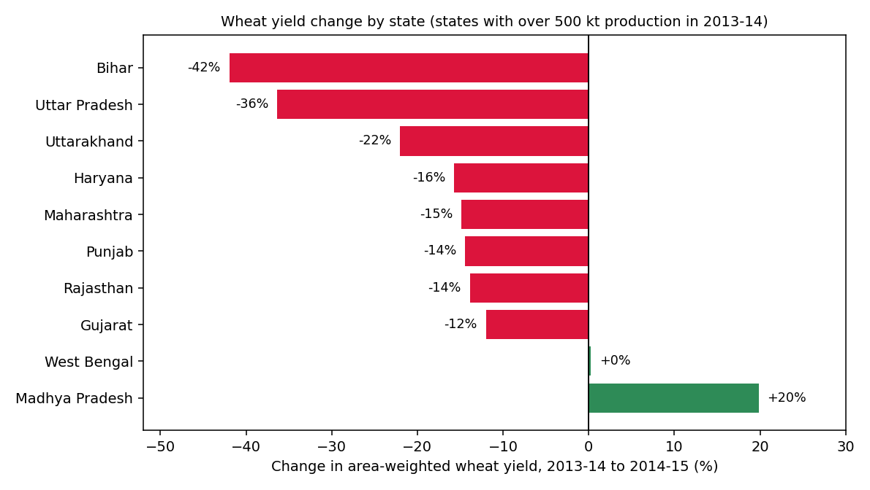
Figure 5: Change in area-weighted wheat yield by state, 2013-14 to 2014-15.
- It was broad. Eight of the ten largest wheat states fell. In million tonnes of production: Uttar Pradesh -11.4, Punjab -2.6, Bihar -2.6, Haryana -1.3, Gujarat -1.3, Rajasthan -1.2; Madhya Pradesh offset this with +2.7. Uttar Pradesh accounts for about 64% of the net national loss; Bihar had the sharpest percentage fall (-42%).
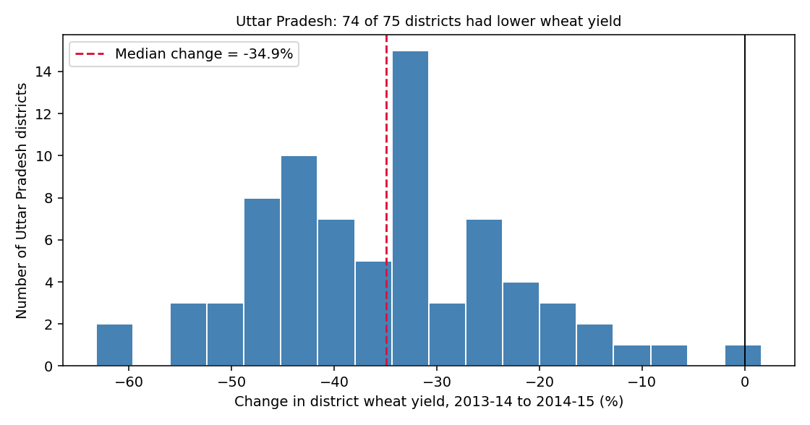
Figure 6: Inside Uttar Pradesh, 74 of 75 districts recorded lower wheat yield; the median fall was 34.9%.
- Inside Uttar Pradesh it was near-universal. 74 of 75 districts fell, 67 by more than 20% and 30 by more than 40%. The largest falls were in Kannauj (-63%), Kanpur Nagar (-61%), Jalaun (-55%), Etawah (-54%) and Kanpur Dehat (-54%).
- It affected all rabi crops, not just wheat. In Uttar Pradesh the 2014-15 yields of Barley (-41%), Gram (-31%), Mustard (-23%) and Masoor (-22%) also fell, alongside wheat (-36%). A shock that hits every winter crop points to a season-wide cause such as weather, not a wheat-specific problem.
- It recovered. Uttar Pradesh's area-weighted wheat yield was 2.04 t/ha in 2014-15, 2.79 in 2015-16 and 3.54 in 2016-17; the national figure moved from 2.72 to 3.11 to 3.57.
What external reports say, and what the data can and cannot show
Press, industry and Wikipedia sources describe unseasonal rain and hailstorms in March 2015, when rabi crops were nearly ready for harvest, damaging wheat and mustard in Uttar Pradesh and other northern and central states (Appendix C). The timing and the all-rabi-crop pattern are consistent with that account. However, this dataset has no weather variables, so weather is a strongly supported hypothesis, not a result. One mismatch deserves follow-up: the same reports mention damage in Madhya Pradesh, yet the data show Madhya Pradesh's yield rising 20%. A weather-affected 2013-14 base year or district reporting practice may explain it, but this has not been verified.

3.4 Statistical and predictive findings from the farm data (Week 4)
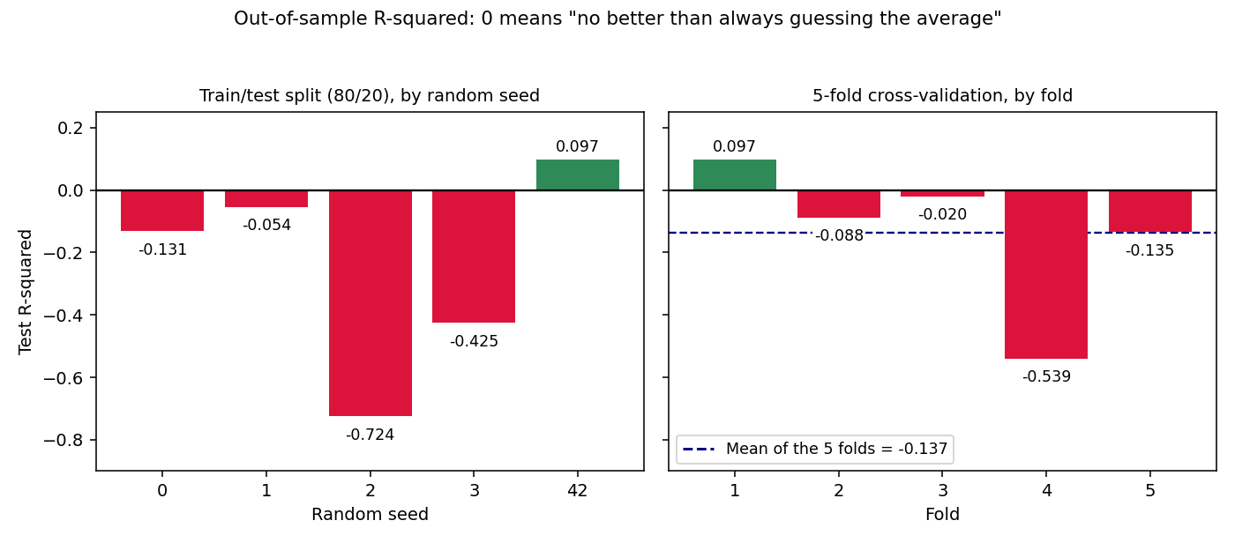
Figure 7: Out-of-sample R-squared of the farm yield model by random split and by cross-validation fold. Values below zero are worse than always guessing the average.
- No input or group showed a significant relationship with yield. Four correlations (area, fertilizer, pesticide, water; r from -0.09 to 0.15, all p above 0.28) and four group comparisons (irrigation, soil, season, crop type; all p above 0.24) were all non-significant.
- The regression model has no predictive skill. R-squared was 0.048 (adjusted -0.036; overall F-test p = 0.685). One train/test split looked promising (R-squared 0.097), but four of five random splits were negative and five-fold cross-validation averaged -0.137. The model's assumptions were largely acceptable (variance inflation factors 1.02 to 1.07), so the weakness is in the data, not the technique.
- The sample cannot detect weak effects. At 50 farms only correlations near 0.39 or stronger can be reliably detected. About 85 farms are needed for r = 0.30 and about 347 for r = 0.15.
Implication: this dataset must not be used to advise farmers on fertilizer, pesticide or water. The finding does not show that inputs do not matter; it shows these 50 records cannot demonstrate it.

4. Business Insights: Linking Findings to Agribusiness Challenges
The table links each analytical result to a challenge an agribusiness faces, states the insight, and says what follows for decisions.
Business challenge | Evidence | Insight | Implication for decisions
Climate and weather risk to supply | 2014-15: yield -16.4%, production -18.0 Mt, area flat; 74 of 75 UP districts down; all rabi crops fell | Supply risk is concentrated in a few large states and is correlated across districts and crops | Procurement, storage and lending plans need shock scenarios, and risk tools must suit widespread, same-season losses
Decision quality of reporting | Pooled mean 69.6 vs median 1.07; pooled r 0.04 vs 0.85-0.94 per crop; all-crop trend +79% vs +45% mix-adjusted | Blended averages describe the crop mix, not performance | Standardise crop- and state-level, area-weighted metrics with sample sizes
Data trust and governance | 5,009 false-zero yields; 3,997 ambiguous zeros; 14.6% false outlier rate under a naive rule | Data defects can silently create false signals of crop failure or recovery | Data-quality controls are a prerequisite for any forecasting or insurance product
Regional productivity gaps | Sugarcane: 77% of Chhattisgarh and 100% of Meghalaya records under 5 t/ha. Wheat 2013-14 yield ranged from 1.4 t/ha (Maharashtra) to 5.0 (Punjab) | Large, persistent gaps exist, but causes (irrigation, soil, variety, reporting) are unverified | Verify causes before investing; target programmes only where the gap is real
Input efficiency and advisory services | 50 farms: no significant input or group effects; cross-validated R-squared -0.137 | Current farm data cannot support input recommendations | Withhold advice; invest in better data (weather, soil, more farms)
Long-run productivity and capacity planning | Wheat yield +43.2% over 25 years, with a steeper rise after 2015 | Underlying productivity grows steadily, punctuated by shocks | Plan capacity on the trend, and hold buffers for shock years
Market competitiveness and pricing | Not analysed: price and trade sources were identified but not used | A supply shock of about 18 Mt is the kind of event likely to matter for prices and trade, but the link is untested here | Treat price and trade strategy as the first priority for further research (Section 10)

5. Strategic Recommendations
Seven recommendations follow. Each states the evidence, the action, the benefits, the pitfalls and how to reduce them, a feasibility assessment, and how success would be measured. They are grouped by the objective they mainly serve: operational efficiency (R1, R3, R4, R7), market competitiveness and growth (R5, R7) and overall business performance and resilience (R1, R2, R6).

R1. Build a climate-shock early-warning and response protocol for the rabi wheat belt
Evidence: In 2014-15 production fell about 18.0 Mt (17.5%) with area unchanged; Uttar Pradesh was 31% of national wheat area and about 64% of the net loss; losses were near-universal across its districts and across rabi crops; external reports link the season to unseasonal rain and hail shortly before harvest.
Action: Monitor forecasts and alerts in the pre-harvest window (roughly February to April) for the highest-exposure states (Uttar Pradesh, Bihar, Punjab, Haryana, Rajasthan); trigger rapid district-level damage assessment; and adjust procurement, transport and storage plans when thresholds are crossed.
Benefits: Earlier and better-sized procurement decisions, fewer stock-outs or distress purchases, faster response to affected districts, and a documented basis for dealing with lenders and partners after a shock.
Pitfalls and mitigation: False alarms can cause alert fatigue and unnecessary cost: set thresholds from historical events and review them each season. Forecast uncertainty means some shocks will be missed: pair alerts with post-event assessment. Annual district data lag events: add near-real-time sources. The protocol depends on weather data that are not yet integrated: make that integration the first task.
Feasibility: Medium effort. Owner: procurement and risk teams with state agriculture departments. Dependencies: a weather data feed (for example IMD), district contacts. A pilot in one or two states is realistic within 3 to 9 months.
Success measures: Time from alert to completed district assessment; share of affected districts assessed within the target window; gap between planned and actual procurement in shock years.

R2. Pilot weather-index insurance or risk-sharing in the highest-exposure districts (conditional)
Evidence: The 2014-15 shock hit most districts of a state at once (74 of 75 in Uttar Pradesh), which is the kind of widespread, weather-driven loss that index-based products are designed for and that is hard for conventional farm-by-farm insurance to absorb.
Action: First establish a district-level relationship between weather indicators and yield using the APY data and weather data (see R7 and Section 10). If that relationship holds, design a pilot with an insurer and a state partner for a small set of districts and one crop.
Benefits: Faster payouts, lower verification cost, and income protection that supports lender repayment and continued input use after a bad season.
Pitfalls and mitigation: Basis risk (the index can pay out when a farm is not hurt, or fail to pay when it is) is the main risk: calibrate at district level and test against historical shocks before launch. Affordability and trust can limit take-up: involve farmer groups and keep contracts simple. The product must not be launched on the strength of this report alone, since no weather-yield model exists yet.
Feasibility: Higher effort and dependent on R7 and weather data. Owners: insurer, state agriculture department, a participating agribusiness. Realistic only after about 12 months, as a pilot.
Success measures: Take-up rate in pilot districts; share of insured farms reporting that payouts matched their losses; time from event to payout.

R3. Make crop- and state-segmented, area-weighted reporting the standard
Evidence: Pooled mean 69.6 versus median 1.07 t/ha; pooled area-production correlation 0.04 versus 0.85 to 0.94 per crop; the all-crop yield rise of +79% falls to +45% once the crop mix is fixed, against Wheat's +43.2%.
Action: Define standard metrics: yield as total production divided by total area, reported per crop and per state, always shown with the number of records behind it. Prohibit blended all-crop averages in dashboards unless the crop mix is held constant and labelled. Use area-weighted, not simple, averages for state and national figures.
Benefits: More trustworthy KPIs, fewer wrong investment signals, and a consistent language across teams.
Pitfalls and mitigation: More metrics can overwhelm users: provide a short default view and drill-down. Small groups give noisy averages: show sample sizes and suppress or flag cells with few records. Needs agreement across teams: assign one owner for metric definitions.
Feasibility: Low effort and low cost; mostly definitions and dashboard changes. Achievable in 1 to 3 months.
Success measures: Share of yield and production reports that follow the standard; share of KPIs shown with sample sizes.

R4. Install data-quality controls, in-house now and at source later
Evidence: 5,009 records (1.1%) with unreported production recorded as zero yield; 3,997 zero-production records that cannot be classed as failure or gap; 14.6% of records wrongly flagged by a global outlier rule.
Action: In-house now: treat a zero yield with missing production as null, keep flagged records with documented inclusion rules, and run per-crop outlier checks before each analysis. At source (with data owners): record unreported production as null, add a mandatory harvest-status field (for example Normal, Total failure, Not reported), and validate each record against crop-specific yield ranges before publication.
Benefits: Cleaner inputs, reproducible analytics, and a clear way to separate real crop failures from reporting gaps, which every later product (forecasts, insurance, alerts) depends on.
Pitfalls and mitigation: Source-level changes depend on other organisations and add reporting burden: pilot in two or three states first and keep the form short. Over-strict validation could suppress genuine extreme events: send out-of-range records for review rather than rejecting them automatically.
Feasibility: Medium effort. In-house controls are achievable within about 6 months. Source-level changes may take 12 to 18 months and require partnership with state agriculture departments.
Success measures: Records with unexplained zero or null values (baseline 5,009 and 3,997); share of zero-production records carrying a status; time taken to resolve out-of-range records.

R5. Verify, then target, the low-yield Sugarcane regions
Evidence: 869 of 12,367 Sugarcane records (7.0%) are below 5 t/ha, 827 of them valid and unflagged; the share reaches 100% in Meghalaya, 84% in Jammu and Kashmir and 77% in Chhattisgarh; the pattern recurs over many years.
Action: Step 1 (verify): check the dataset codebook and units for these states, sample a few districts on the ground, and obtain irrigation coverage data. Step 2 (target): only where the gap is confirmed as real, pilot irrigation, variety or agronomy support in selected districts, with comparison districts.
Benefits: A potentially large productivity gain in underperforming regions if the cause is confirmed, and avoided wasted spending if the cause is a reporting convention.
Pitfalls and mitigation: The cluster may reflect a different product definition or unit (for example Sugarcane grown for jaggery rather than for mills), in which case investment would be misplaced: this is why verification comes first. Irrigation expansion raises water-use and sustainability questions. The affected area may be small relative to national output, so size the opportunity before committing.
Feasibility: Medium effort. Verification can be done in about 3 to 6 months at low cost; a pilot would take 12 to 18 months. Owners: agribusiness research and extension teams with state departments.
Success measures: Verification outcome (real gap, reporting artefact or mixed); yield change in pilot districts against matched comparison districts.

R6. Invest in a farm-level data programme before offering input advice
Evidence: Fifty farms showed no significant input or group effects and no predictive skill; weather, soil and sowing-date variables are absent; about 85 farms are needed to detect a moderate effect (r = 0.30) and about 347 for a weak one (r = 0.15).
Action: Collect, with consent, rainfall, temperature, soil tests (nutrients, pH), sowing dates and input records for at least about 350 farms, with at least 30 farms per crop where per-crop models are needed. Fix the analysis plan in advance and report effect sizes with confidence intervals.
Benefits: A future evidence base for input recommendations, and protection against giving advice that the data cannot support.
Pitfalls and mitigation: Cost, farmer time and data-privacy concerns: use clear consent, anonymised IDs and simple collection (mobile forms, extension staff). Even with better data, effects may remain weak: plan for that and treat a null result as useful. Selection bias if only easier-to-reach farms enrol: sample across farm sizes and regions.
Feasibility: Higher effort and cost, over 12 to 24 months. Owners: agribusiness research team with extension services and farmer organisations.
Success measures: Farms enrolled; share of records with complete weather and soil data; cross-validated R-squared of any later model compared with the baseline.

R7. Build a validated yield-monitoring and forecasting capability on the APY data
Evidence: The APY dataset has 450,350 analysis-ready records over 26 years, enough for per-crop and per-state trend and shock models, unlike the 50-farm dataset. Week 4 showed how easily a single favourable split (R-squared 0.097) can mislead when repeated validation gives -0.137.
Action: Start with per-crop, per-state trend models (for example Wheat yield against year) with prediction intervals; add weather variables when available; use time-aware validation (train on earlier years, test on later ones) and always compare against a simple baseline such as a recent-years average.
Benefits: Better planning of procurement, storage and logistics, and a measured basis for any pricing or contracting decisions that depend on expected supply.
Pitfalls and mitigation: Structural breaks such as 2014-15 can break a trend model: include shock indicators and show intervals, not single numbers. Annual data are slow: use the model for planning, not for real-time alerts. Models degrade over time: schedule re-validation each season.
Feasibility: Medium effort. A prototype for one crop and a few states is realistic in 3 to 6 months, with expansion over 12 to 24 months. Owner: analytics team.
Success measures: Forecast error compared with the baseline on held-out years; share of actual outcomes falling inside the prediction interval.

5.8 Priority, effort and fit with business objectives
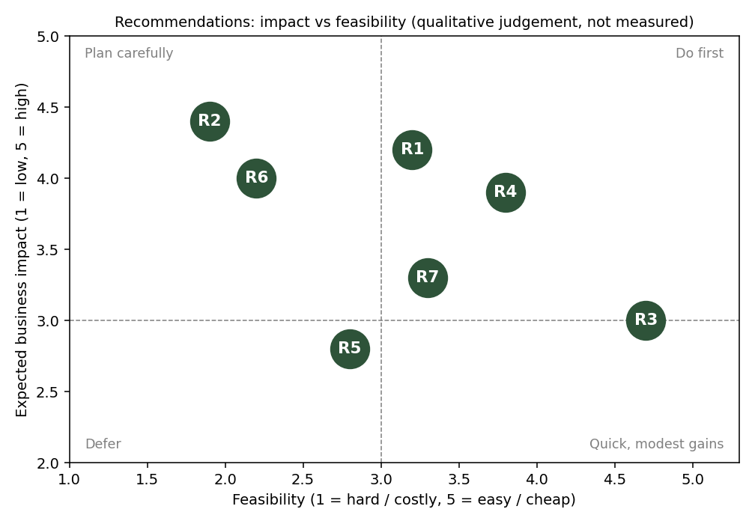
Figure 8: Impact and feasibility of the seven recommendations (a qualitative judgement for prioritisation, not a measured result).
Rec. | Priority | Effort | Main objective served | Time to first result
R3 Segmented reporting | 1 (do first) | Low | Operational efficiency | 1-3 months
R4 Data-quality controls | 1 (do first) | Medium | Operational efficiency; enabling for all | In-house 6 months; source 12-18 months
R1 Early-warning protocol | 2 (pilot) | Medium | Resilience; operational efficiency | 3-9 months
R7 Forecasting capability | 2 (pilot) | Medium | Operational efficiency; market planning | 3-6 months (prototype)
R5 Verify, then target Sugarcane | 3 (verify first) | Medium | Growth and competitiveness | Verification 3-6 months
R6 Farm data programme | 3 (long-term) | High | Evidence for future input advice | 12-24 months
R2 Weather-index insurance | 4 (conditional) | High | Resilience | 12+ months, after R7 and weather data

6. Benefits and Pitfalls: Cross-Cutting View
Beyond the recommendation-specific points above, several risks apply to the programme as a whole.
Theme | Potential benefit | Pitfall | Mitigation
Reliance on administrative district data | Broad coverage over 26 years at low cost | Reported figures may contain estimation or reporting-practice effects (for example season labels changed in 2014-15) | Run robustness checks as done here; document definitions; verify anomalies on the ground
Association is not causation | Patterns point to where to look | Acting on a pattern as if it were a proven cause (for example attributing the 2014-15 dip to weather) | Label hypotheses as hypotheses; test with added data (weather, irrigation) before large commitments
Averages hide variation | District and state summaries are easy to communicate | A district average can hide that some farms did well and others failed | Use farm-level data where decisions affect individual farmers; report spread as well as averages
Model overconfidence | Forecasts support planning | A model that looks good on one split but has no skill (R-squared 0.097 versus -0.137) | Require repeated or time-aware validation and a baseline comparison before any model is used
Cost and capacity | Phased plan spreads effort | Data programmes and pilots need budget and skilled staff | Start with low-cost quick wins (R3, R4 in-house); gate larger spending on pilot results
Institutional coordination | Source-level fixes benefit every user of the data | Depends on organisations outside the business's control | Pilot with willing partners; share results and tools
Farmer privacy and fairness | Better services and risk tools | Data collection without clear consent; labelling small groups of farmers on noisy averages | Informed consent, anonymised IDs, minimum group sizes before reporting

7. Implementation Roadmap and Success Measures
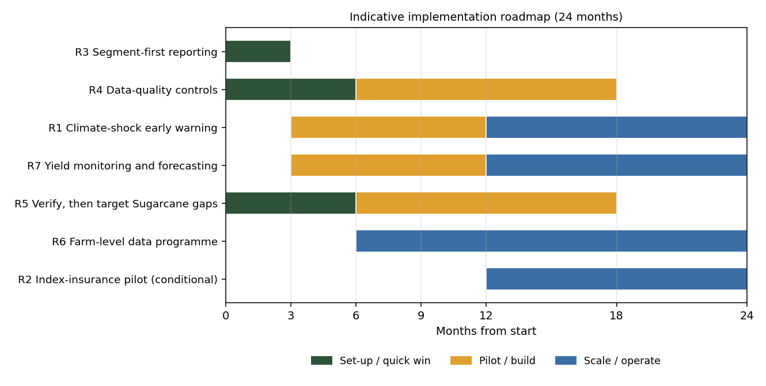
Figure 9: Indicative 24-month roadmap. Timings are planning estimates, not commitments.
The sequence follows dependencies: segmented reporting and data-quality controls come first because every later product relies on trustworthy, correctly summarised data; forecasting and early warning are piloted next; the farm data programme and any insurance pilot, which need more data and partners, come last.

7.1 Success measures and baselines
Baselines come from the analyses in this project. Where no baseline exists yet, the target is set after a first measurement period rather than guessed.
Measure | Linked to | Baseline from this analysis | Target approach
Records with false-zero yield (production unreported) | R4 | 5,009 of 455,359 (1.1%) | Zero at each release
Zero-production records without a status explanation | R4 | 3,997 of 450,350 (0.89%) | All records classified
Yield reports using crop-level, area-weighted metrics with sample sizes | R3 | Not tracked | All yield KPIs
National wheat area-weighted yield (t/ha) | R1, R7 | 3.26 (2013-14), 2.72 (2014-15 shock), 3.57 (2016-17) | Track against trend; set after multi-year baseline
Time from alert to completed district assessment | R1 | Not measured | Set during pilot
Forecast error versus simple baseline, on held-out years | R7 | No APY model yet; farm model cross-validated R-squared -0.137 | Beat the baseline in repeated validation
Sugarcane low-yield share in pilot districts | R5 | e.g. Chhattisgarh 77% of records below 5 t/ha | Set after verification
Farms with complete weather and soil records | R6 | 0 (farm data lacks these variables) | At least about 350 (30 per crop)

8. Responsible Use, Ethics and Governance
- Honest communication of uncertainty. Every recommendation here rests on associations in observational data. Reports based on them should state what is known (for example the size and breadth of the 2014-15 shock), what is hypothesised (the weather cause) and what is unknown (price effects, causes of the Sugarcane gap).
- No decisions about individual farmers from district averages. District and state figures describe groups. Using them to judge or price risk for an individual farmer would be unfair and statistically unsound.
- Consent and privacy in new data collection (R6). Farm records should be collected with informed consent, stored with anonymised identifiers, and shared only in aggregated form. The provenance and licence of the Kaggle farm dataset used in Week 4 are not documented and should be confirmed before reuse.
- Equity. Insurance and advisory products can leave out smallholders if they are priced or designed for larger farms. Pilots should record who participates and who does not.
- Transparency of analysis. All tests, splits and flags are reported, including unfavourable ones, and the analysis plan should be fixed before new data are examined to avoid cherry-picking results.

9. Limitations of the Overall Evidence
- Scope: only two of the five sources identified in Week 1 were analysed. Price, trade and supply-chain evidence is absent, so conclusions on market competitiveness are indirect.
- No weather variables: the 2014-15 explanation and recommendations R1 and R2 rest on external reports and the pattern in the data, not on a tested weather-yield model.
- District-level, reported data: figures are administrative estimates and cannot show variation between farms within a district.
- Unverified anomalies: the Sugarcane low-yield clusters and the Madhya Pradesh increase in 2014-15 are unexplained; both could involve reporting conventions or base-year effects.
- Small farm sample: 50 farms limit power; results cannot be generalised to other regions or years, and the dataset's origin (real or simulated) is unknown.
- Methodological choices: outlier rules, the decision to drop 5,009 records, and the area-weighted summaries are judgements; alternatives could change specific numbers, though robustness checks (Section 3.3) suggest the main conclusions are stable.
- External sources were used for context only, were not independently verified, and were not used in any calculation.

10. Further Research
- Test the weather hypothesis directly: join district rainfall and temperature to the APY data and compare 2014-15 yield changes between districts that did and did not experience extreme weather.
- Analyse prices and markets: relate Agmarknet-style price data to yield shocks (price-yield correlation, price volatility) to build the missing market-competitiveness evidence.
- Analyse trade: compute the export competitiveness KPI from FAOSTAT data, as planned in Week 1.
- Map climate exposure: calculate district-level yield volatility (for example the coefficient of variation) from the APY data to rank districts by risk, a task possible with data already in hand.
- Audit units and definitions in the APY data for Sugarcane and Coconut by state, and test the irrigation hypothesis with district irrigation-coverage data.
- Build per-crop and per-state trend and shock models with prediction intervals and time-aware validation; later add weather covariates.
- Build a farm-level panel (weather, soil, inputs, repeated seasons) and use multilevel models so crops can share information without being forced onto one scale.
- Study post-harvest and supply-chain losses (storage, transport, spoilage), for which no data have yet been collected.
- Examine equity: compare outcomes by farm size and region once farm-size data are available.

11. Conclusion
Five weeks of analysis lead to a consistent message. The public data are usable, but only after careful cleaning and only when read crop by crop and state by state: pooled averages and correlations repeatedly misled until they were segmented. Within that discipline, the data show a steadily improving wheat sector punctuated by large, broad weather-type shocks, of which 2014-15 is the clearest, with Uttar Pradesh at its centre. They also show regional productivity gaps that need verification, and they show that a small farm-level dataset cannot support input advice or yield prediction.
The recommendations follow from this: fix reporting and data quality first, because they are cheap and enable everything else; pilot early warning and forecasting where the evidence is strongest; verify before investing in regional programmes; and invest in the data needed to answer the questions this project could not. The programme's most important safeguard is intellectual honesty about what the evidence supports. The 2014-15 shock is a real and costly event whose cause is probably weather, and the next step is to prove that with weather data, not to assume it.

Appendix A. Data Sources Register
Source | Provider | Used in | Notes
Crop-Wise Area, Production and Yield (APY): https://indiadataportal.com/p/area-production-yield-apy/r/moafw-area_production_yield-dt-sn-qzf | India Data Portal; Directorate of Economics and Statistics, Ministry of Agriculture and Farmers Welfare | Weeks 2, 3, 5 | Open Data Commons Attribution License; 455,359 raw rows, 16 columns
Agriculture and Farming Dataset: https://www.kaggle.com/datasets/bhadramohit/agriculture-and-farming-dataset | Kaggle (user bhadramohit) | Weeks 1, 4 | 50 farms, 10 columns; provenance and licence to be confirmed
FAOSTAT Trade: Crops and Livestock (Asia): https://www.fao.org/faostat/en/#data/TCL | FAO | Week 1 (described) | Not analysed; recommended for trade analysis
World Bank Data360, FAO/WB agricultural commodity indices: https://data360.worldbank.org/en/search | World Bank | Week 1 (described) | Not analysed; recommended for price analysis
World Bank Agriculture and Rural Development: https://data.worldbank.org/topic/agriculture-and-rural-development | World Bank | Week 1 (described) | Not analysed; macro context

Appendix B. Key Numbers Reference
Quantity | Value | Origin
APY raw rows / analysis-ready rows | 455,359 / 450,350 | Week 2
Rows removed (missing production) | 5,009 (1.1%) | Week 2
Per-crop outliers / global-method outliers | 14,453 (3.21%) / 65,857 (14.6%) | Week 2
Crop-failure flags (area > 0, production = 0) | 3,997 (0.89%) | Week 2
Records flagged either way | 18,448 (4.10%); 2 carry both flags | This report
Pooled yield: mean / median / std. dev. (t/ha) | 69.61 / 1.07 / 866.46 | Week 3
Area-production correlation: pooled / Wheat / Rice / Maize / Sugarcane | 0.04 / 0.936 / 0.898 / 0.852 / 0.929 | Week 3
Wheat yield 1997 to 2022 (t/ha) | 1.904 to 2.726 (+43.2%) | Week 3
All-crop mean yield 1997 to 2022; with 1997 crop mix fixed | 45.6 to 81.7 (+79%); 45.6 to 65.9 (+45%) | This report
Sugarcane records below 5 t/ha | 869 of 12,367 (7.0%); 42 flagged crop failure, 0 outliers | Weeks 3, 5
National wheat area-weighted yield: 2013-14 / 2014-15 / 2015-16 / 2016-17 (t/ha) | 3.257 / 2.724 / 3.112 / 3.572 | This report
National wheat production 2013-14 / 2014-15 | 102.97 Mt / 84.96 Mt (-18.01 Mt, -17.5%) | This report
Uttar Pradesh wheat: area share / yield change / share of net production loss | 31.1% / -36.4% (3.20 to 2.04 t/ha) / 63.5% | This report
UP districts with lower wheat yield; median change | 74 of 75; -34.9% | This report
UP yield change 2014-15: Barley / Gram / Mustard / Masoor | -41.3% / -31.1% / -23.4% / -22.3% | This report
Farm model: R-squared / adjusted / F-test p | 0.048 / -0.036 / 0.685 | Week 4
Farm model: cross-validated R-squared (5-fold) | -0.137 | Week 4
Farms needed for r = 0.30 / r = 0.15 (80% power) | About 85 / 347 | Week 4

Appendix C. External Context Sources
These sources were consulted for context on the 2014-15 season only. They were not used in any calculation and were not independently verified; their statements are paraphrased.
- Wikipedia, 'March 2015 North India unseasonal rain': https://en.wikipedia.org/wiki/March_2015_North_India_unseasonal_rain. Describes unseasonal rain and hail damaging rabi crops in March 2015, naming wheat and mustard in Uttar Pradesh, and notes that the government raised compensation and eased claims.
- The Quint, 'In Pictures: Crops Ruined by Unseasonal Rains', 1 April 2015: https://www.thequint.com/news/india/in-pictures-crops-ruined-by-unseasonal-rains. Reports wheat damage in Uttar Pradesh, Madhya Pradesh and Rajasthan after March rains.
- India Water Portal, 'Unseasonal rains damage crops worth Rs 10,000 crore', 3 March 2015: https://www.akvopedia.org/wiki/India_Water_Portal:_Unseasonal_rains_damage_crops_worth_Rs_10,000_crore. Reports heavy rabi damage in Bundelkhand (Uttar Pradesh and Madhya Pradesh), Punjab, Haryana and parts of Maharashtra and Gujarat, and notes hail damage in the previous year as well.
- FICCI Research, 'Impact of Unseasonal Rains', June 2015: https://ficci.in/public/storage/SPDocument/20855/Impact_of_Unseasonal_Rains.pdf. Reports excess rainfall in several states including Uttar Pradesh between 1 March and 6 May 2015, lower expected wheat output, and central-pool wheat stocks of about 17.2 million tonnes on 1 April 2015 as a buffer.
- Down To Earth, 'Unseasonal rainfall damages Rabi crops for seventh consecutive season': https://www.downtoearth.org.in/agriculture/unseasonal-rainfall-damages-rabi-crops-for-seventh-consecutive-year-53169. Describes repeated seasons of rabi damage from unseasonal rain and hail in later years.

Appendix D. Glossary
Term | Meaning
Agricultural year | A season such as 2014-15: sown in 2014, harvested in 2015.
Rabi | The winter-sown, spring-harvested crop season; wheat is the main rabi crop.
Area-weighted yield | Total production divided by total area; larger areas count for more than in a simple average.
Outlier (IQR rule) | A value far outside the middle 50% of a crop's own yields (more than 1.5 times the interquartile range beyond the quartiles).
Crop-failure flag | A marker for records with cultivated area but zero production, kept in the data so that risk analysis can use them.
Correlation (r) | A score from -1 to +1 showing how closely two numbers move together in a straight line.
p-value | How surprising a result would be if nothing real were going on; below 0.05 is conventionally called significant.
ANOVA | A test of whether average outcomes differ between three or more groups.
R-squared | The share of variation a model explains; zero means no better than guessing the average, and out-of-sample values can be negative.
Cross-validation | Testing a model repeatedly on data held back from building it, to measure honest performance.
Baseline | A simple benchmark, such as always predicting the average, that a model must beat.
Basis risk | In index insurance, the gap between the index payout and a farm's actual loss.

